**SPRINT 3 REQUIREMENTS ARTIFACT**

1. A global leaderboard to see who was the most wins (Requirement-ID 17) 13 Story points
2. Make sure the website is accessible on all different browsers (Requirement-ID 18) 13 Story points
3. Add ability to change usernames (Requirement-ID 19) 3 Story points
4. Make sure the website is responses and runs fast (Requirement-ID 21) 5 Story points
5. Make website keyboard accessible (Requirement-ID 22) 3 Story points
6. In-game chat feature during tic-tac-toe matches (Requirement-ID 30) 5 Story points
7. Add ability to reset password (Requirement-ID 15) 5 Story points
8. Allow users to select to pick sides against bot (Requirement-ID 33) 3 Story points
9. A global leaderboard to see who was the most wins (Requirement-ID 17) - *User Story*
   1. Users can view the leaderboard to see wins
   2. Users can win more games to climb on the leaderboard
   3. Leaderboard will update as users win games
   4. The leaderboard will show the usernames of the top players
10. Make sure the website is accessible on all different browsers (Requirement-ID 18) - *User Story*
    1. Users can access the sites on a variety of browsers
    2. All aspects of the website should be accessible on all browsers
    3. the website will perform the same for all browsers
11. Add ability to change usernames (Requirement-ID 19) - *User Story*
    1. Users want to change inappropriate usernames
    2. Users prefer to have a new username
12. Make sure the website is responses and runs fast (Requirement-ID 21) - *User Story*
    1. Users experience delays when playing against user
    2. Users experience delays when playing against a computer bot
    3. Users want to see real-time number of likes on a post
    4. Users don't want to wait long loading times for certain features
13. Make website keyboard accessible (Requirement-ID 22) - *User Story*
    1. Website should work with keyboards
    2. laptop keyboard should work correctly with the website
    3. Mobile keyboards should also work correctly with the website
14. Add ability to reset password (Requirement-ID 15) - *User Story*
    1. Users want to reset passwords for security reasons
    2. Users want to reset their password because they occasionally forget their password
15. In-game chat feature during tic-tac-toe matches (Requirement-ID 30)

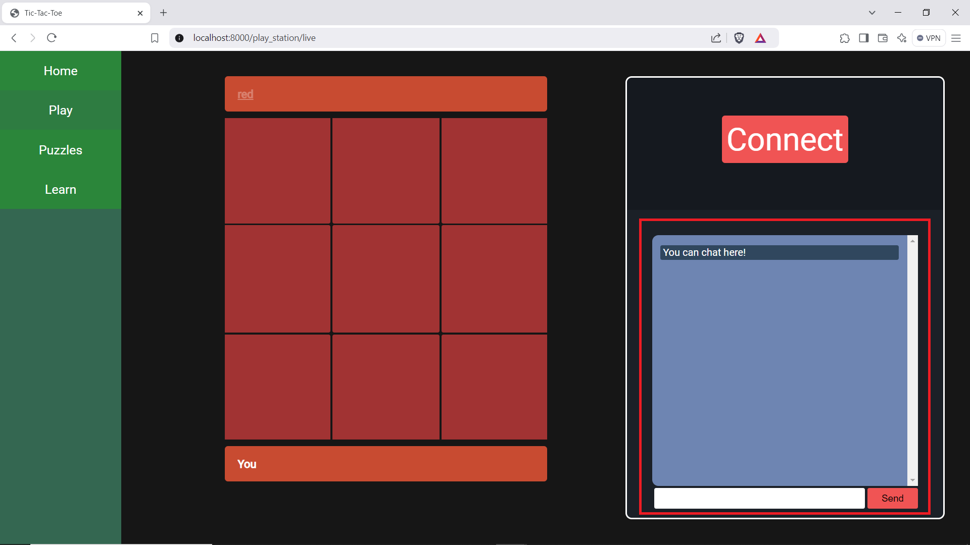

1. Allow users to select to pick sides against bot (Requirement-ID 33)

